CHAPTER – 5

DESIGN AND DEVELOPMENT

#### Project description

#### Platform

#### Module description

#### Live demo pictures

#### 5.1Project Description

#### 

#### The above figure illustrates the working of all over the project.

#### Different types of the sensors are placed in the environment which sense the environment around them and according to that it sends signals to microcontroller.

#### The Microcontroller sense the signal and take appropriate action according to the condition.

#### The Microcontroller control other devices and also send the data online to the database which is used further for website and mobile application which gives real time update of the particular module.

#### Components used:

* + - 1. Arduino Microcontroller
      2. NodeMCU Microcontroller
      3. ESP 8266
      4. Relay Module
      5. LDR Sensor
      6. Water level sensor
      7. Ultrasonic Sensor
      8. LED
      9. LCD display
* **Arduino Uno:**

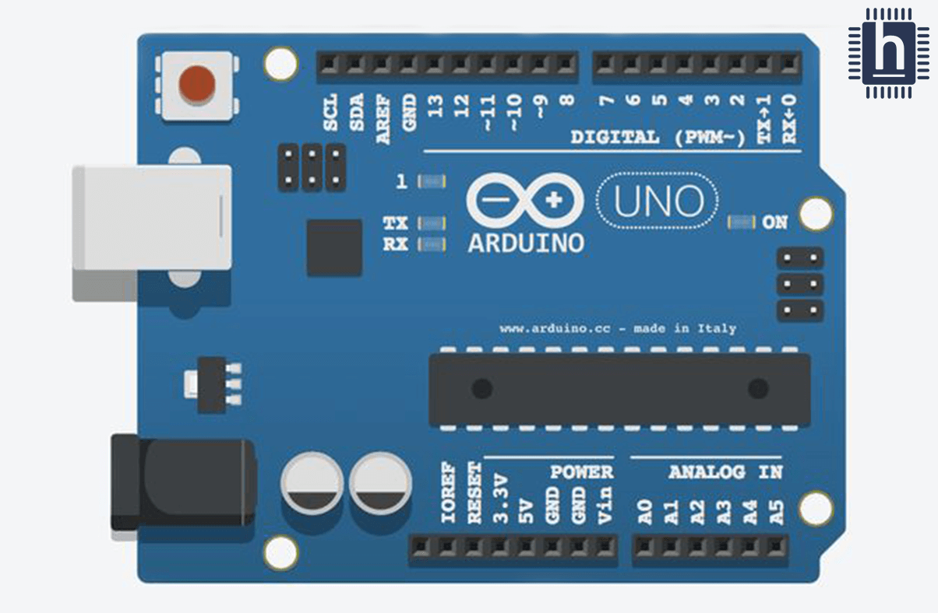

* + Arduino Uno microcontroller board is based on ATmega328P.It has 14 digital input/output pins, 6 analog inputs, a 16 MHz ceramic resonator, a USB connection, a power jack and a reset button. It requires 5 V power supply to activate.
  + We program this microcontroller using Arduino IDE to control all different types of sensors and modules etc.
* **NodeMCU**

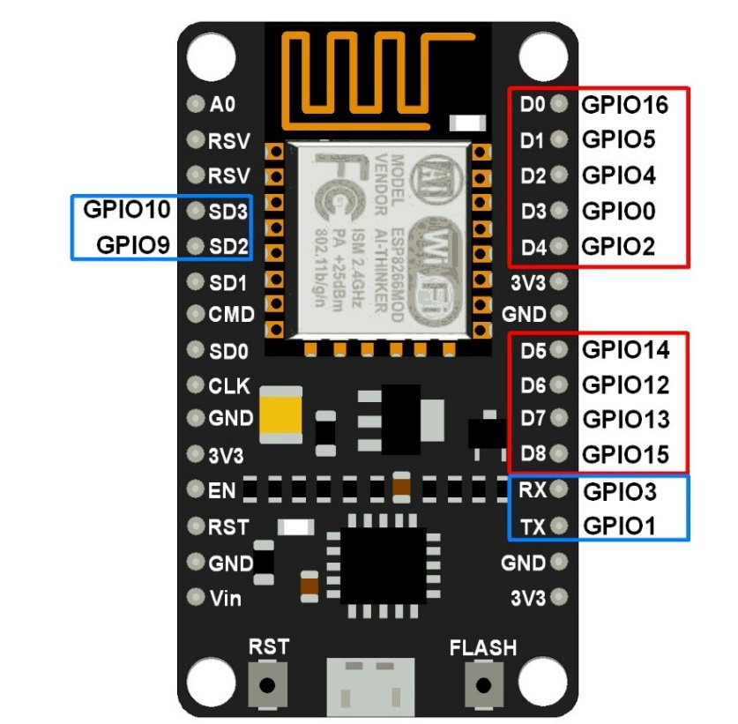

* NodeMCU is also one kind of Microcontroller but what makes NodeMCU so special is that it has in-built Wi-fi Chip.
* NodeMCU has built-in Wifi Module which saves lots of efforts of the developer and makes it easy to connect to the cloud for the developer.
* It also has different GPIO pin which is used as digital pins for sensing he input signal and output pins are used for output purpose.
* **ESP-8266 Wi-Fi Module:**

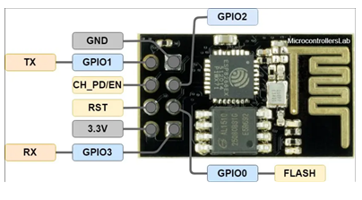

* + ESP-8266 Wi-Fi Module is the main component of our project. It connects our Microcontroller and electronic sensor or module to internet. Using this microcontroller can send the data to database and receive the data from database.
  + In Arduino Microprocessor we need to interface esp-8266 externally and it can be controlled from local Wi-Fi network or internet.
* **Relay Module**

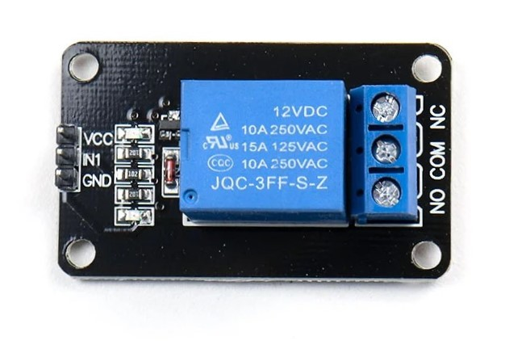

* Relay Module is one kind of mechanical switch which works on 5v to 12v.
* It controls other devices with the help of signal which it receives.
* The relay module separate two different system from each other which work on different voltages.
* **Ultrasonic sensors:**

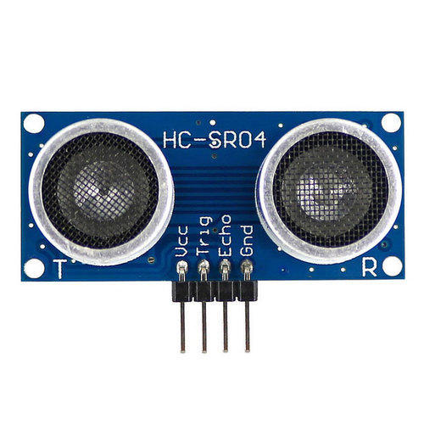

* + Ultrasonic sensor is an electronic device that measure the distance of object by sending ultrasonic sound wave. It has two components.one is transmitter and second is receiver. Transmitter send ultrasonic wave and receiver receives ultrasonic wave. Transmitter send ultrasonic wave and if any object is in front of ultrasonic sensor than the wave is reflected and received by receiver.
  + In order to calculate the distance between the sensor and object, the formula is D=(T*C)/2 where, D is the distance, T is the time, and C is the speed of sound ~ 343 meters/second.
* **LDR Sensor:**

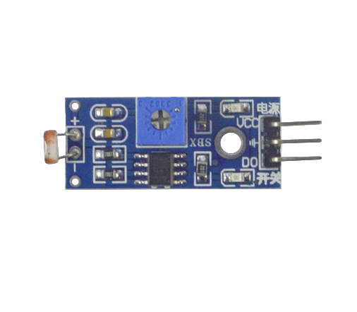

* + LDR sensor is also called photoresistor sensor. When lights fall on it then it gives low signal to the microprocessor if there is not then it gives HIGH signal to microprocessor.
* **LED:**
  + Led is used for the lighting purpose. In our project depends on the current status of Motion Sensor and LDR Sensor it will turn OFF and ON.
* **LCD Display:**

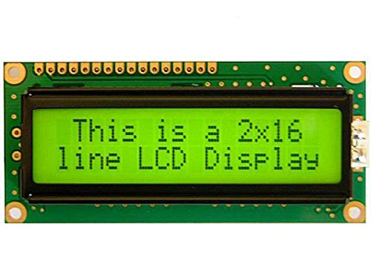

* + LCD require 5v current to operate. LCD used for displaying the data on the screen and it is connected to the microcontroller and depends on program it gives the displaying the data on screen. It can be also used for reading and writing.

#### Platforms:

#### Arduino IDE

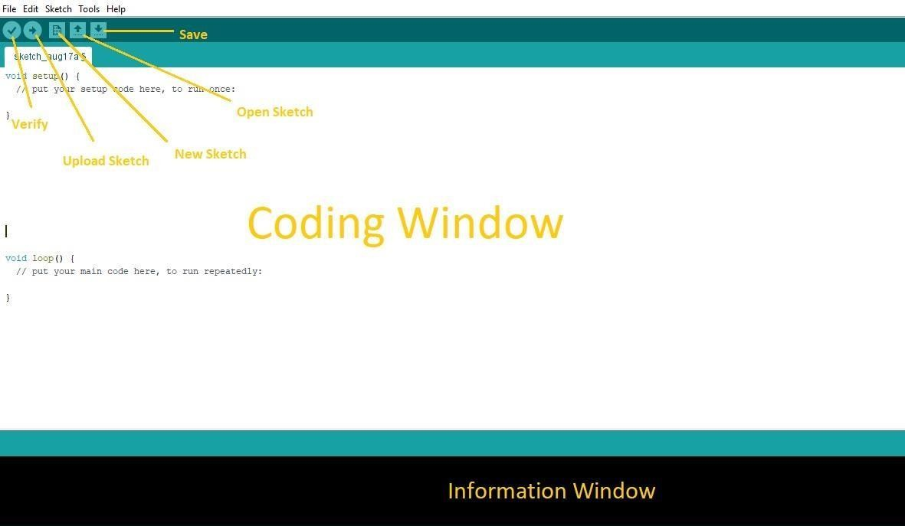

* The Arduino IDE is the tool, which we used to program the micro- controller of the Arduino.
* Arduino software is easy to use and free open source also available for all operating system like Windows, Linux, and Mac etc.
* That software is based on C++ and we can easily write and verify, upload the program in Arduino board.

**Language:** Arduino (Consists: Java, Python, C++, C, etc.)

#### Firebase Database:

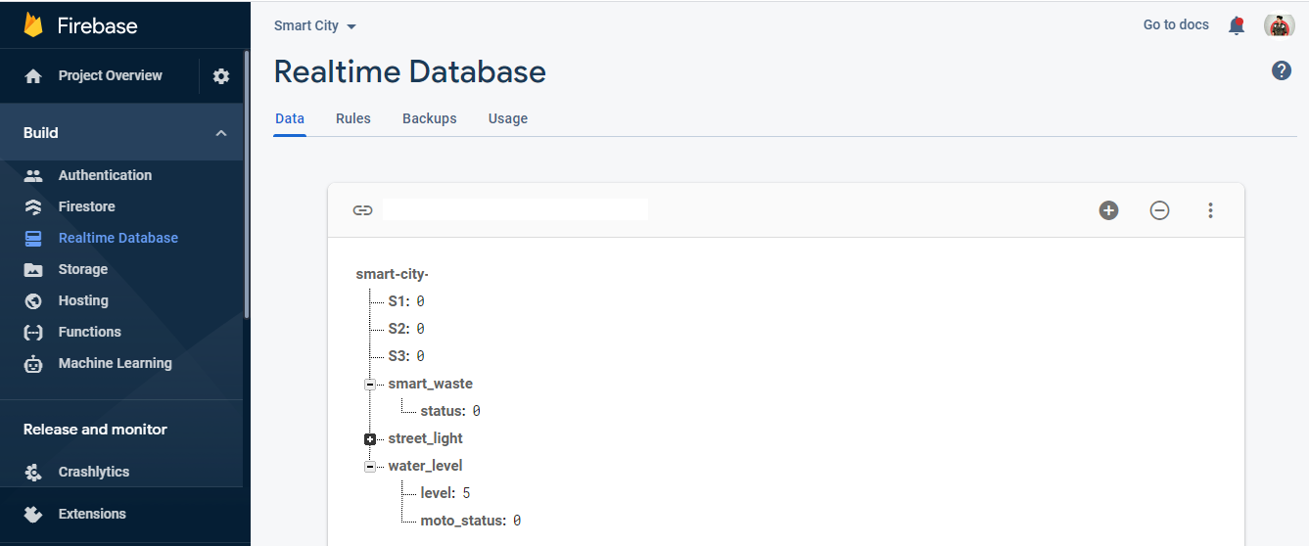

* we have used google firebase real time database for storing the data coming from the microcontroller and we are getting the data from firebase to website or mobile application for displaying the status of our modules in interactive view.
* we are getting the data from the firebase to microcontroller for controlling some electronic modules like water pump.
* Firebase database gives real time updates to the website or mobile application.
* We have used firebase API for getting the real time data from the firebase database to our webpage.

#### Module Description:

#### Smart Parking System

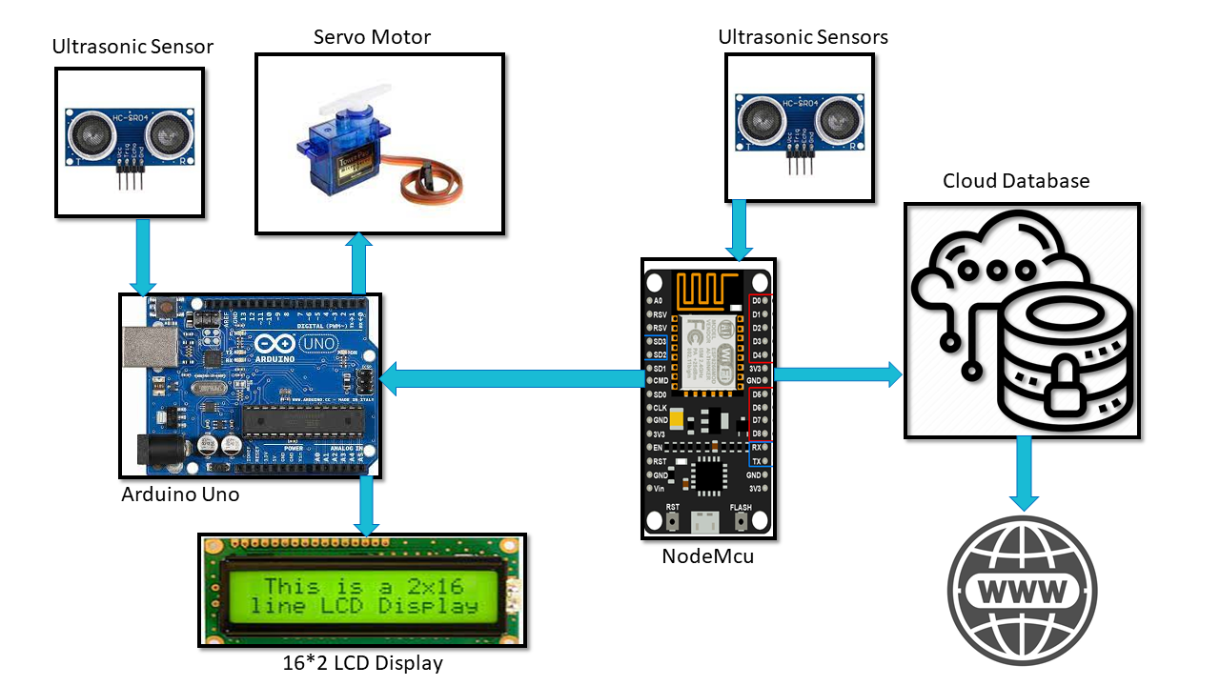

* In smart parking system we have used arduino microcontroller , Nodemcu microcontroller, Ultrasonic sensor, Servo motor, Firebase relatime database, 16*2 lcd display.
* Ultrasonic sensor measure the distance from the object and if the object is near from the given condition then the data sends from arduino microcontroller to nodemcu microcontroller using the software serial library and after reaching the data at nodemcu it sends that data to firebase database and we get that data to our website and arduino for displaying the status of parking area.

#### Smart Waste System

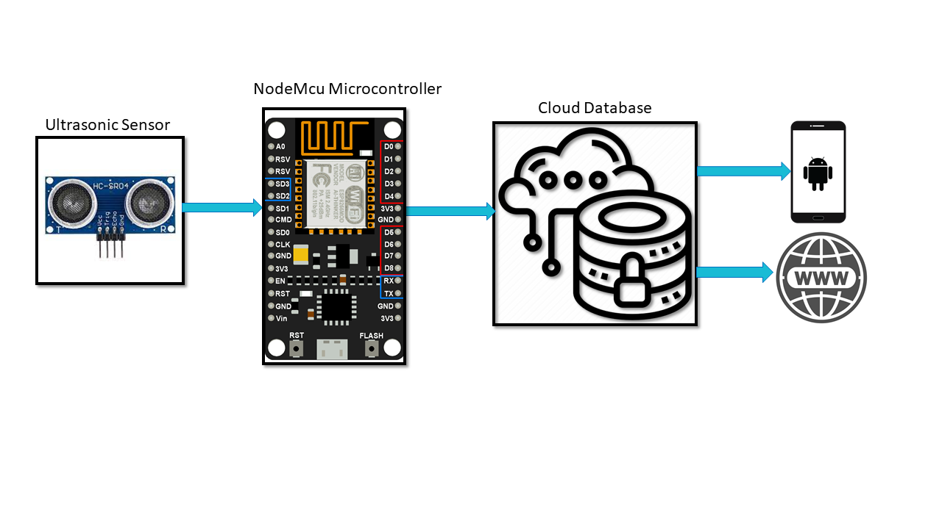

* In smart waste system we have used Nodemcu microcontroller, Ultrasonic sensor, Firebase relatime database, blynk cloud database.
* Ultrasonic sensor measure the distance in the dustbin and if the garbage is near from the given condition then the data sends from nodemcu microcontroller to firebase database or blynk cloud and we get that data to our website and sends the notification to mobile application.

#### Automatic street lights

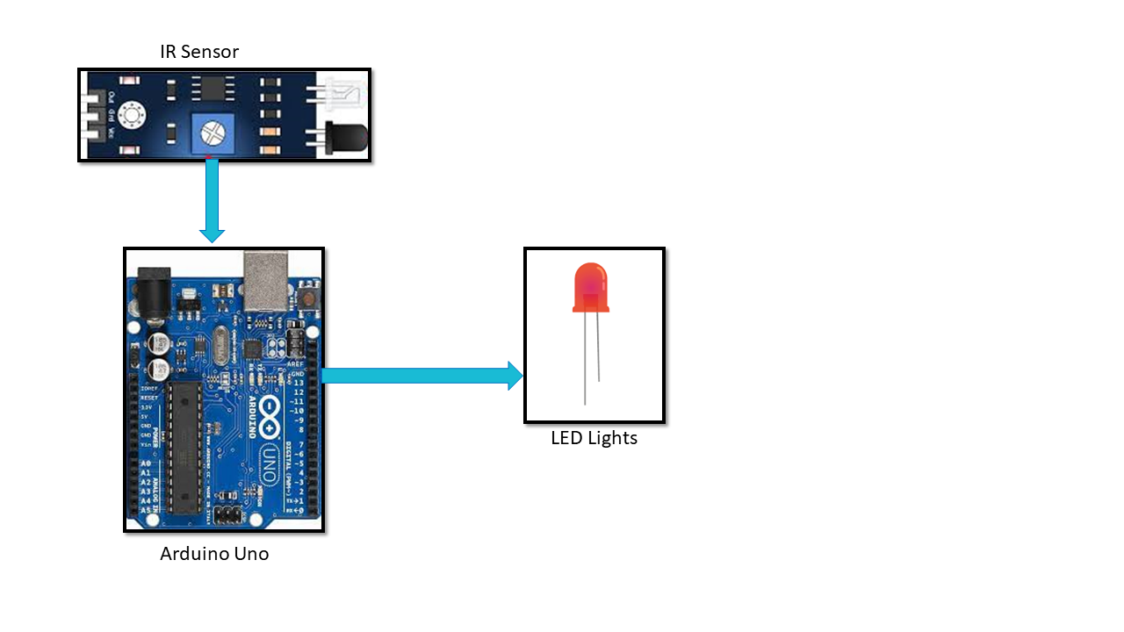

* In Automatic street light, we have used Arduino microcontroller, ldr sensors, ir sensors, led lights.
* LDR sensor is an light dependent sensor which is active in low light so we have used this to measure light and if it sends the signal high then we measure the distance of object from ir or pir sensor if any object is detected then the intensity of led lights are increased and goes to high and if any object is not detected then the intensity of led lights will remains low until any object is detected.

#### Smart Water System

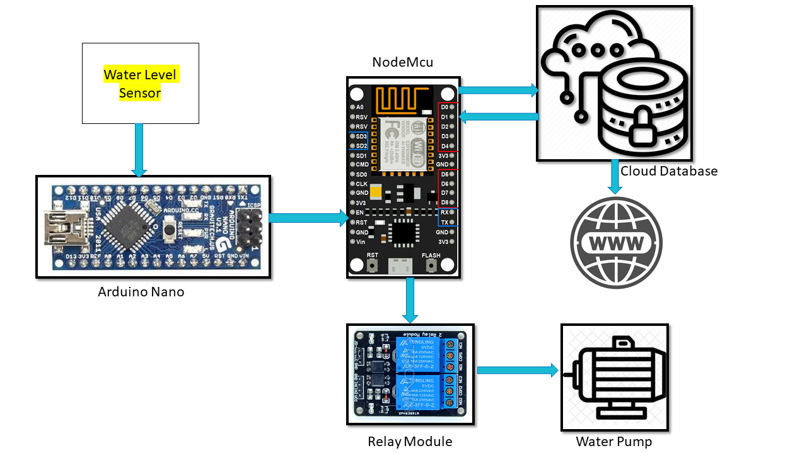

* In smart water system we have used Arduino Nano microcontroller, Nodemcu microcontroller, Relay module, Water level measure sensor, waterpump, led lights, Firebase database.
* Water level measure sensor measure the level of water tank and sends the data related to level to the Arduino nano then after nano send this data to nodemcu using software serial communication. After data coming to node it sends this data to firebase database.
* After stroing the data to database we get that data to microcontroller and depend on the value coming from the firebase database we control relay module.
* Relay module is connected to the water motor and it will be control by Nodemcu microcontroller depend on the data coming from database.

#### Live Demo Pictures:

#### Website Images:

#### Login

#### 

#### Register

#### 

#### Parking System:

#### 

#### Water System:

#### 

#### Smart Parking System

#### 

#### 

#### 

#### 

#### Smart Waste System

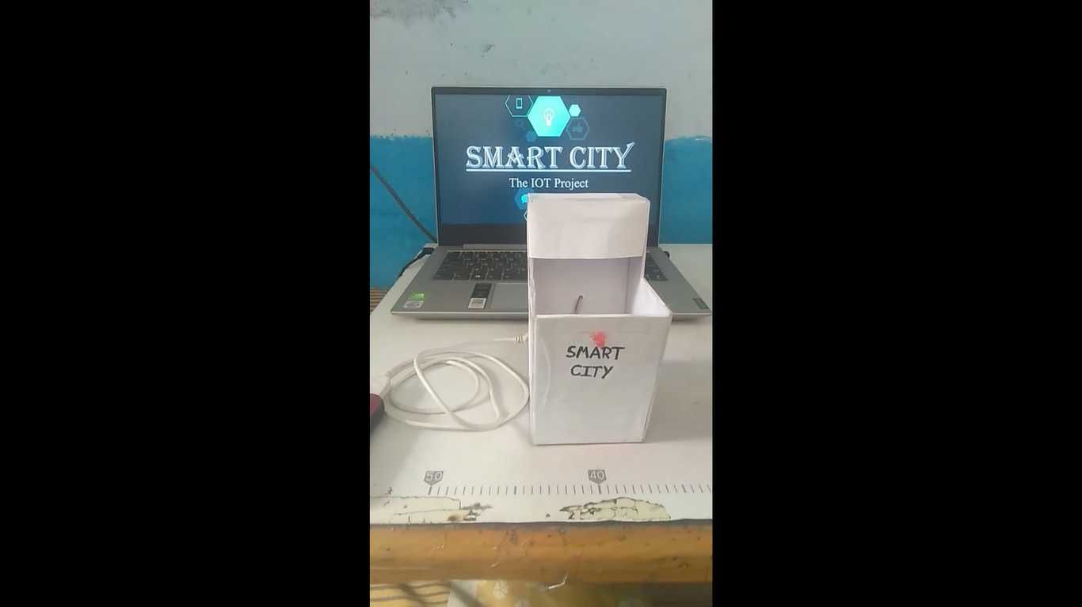

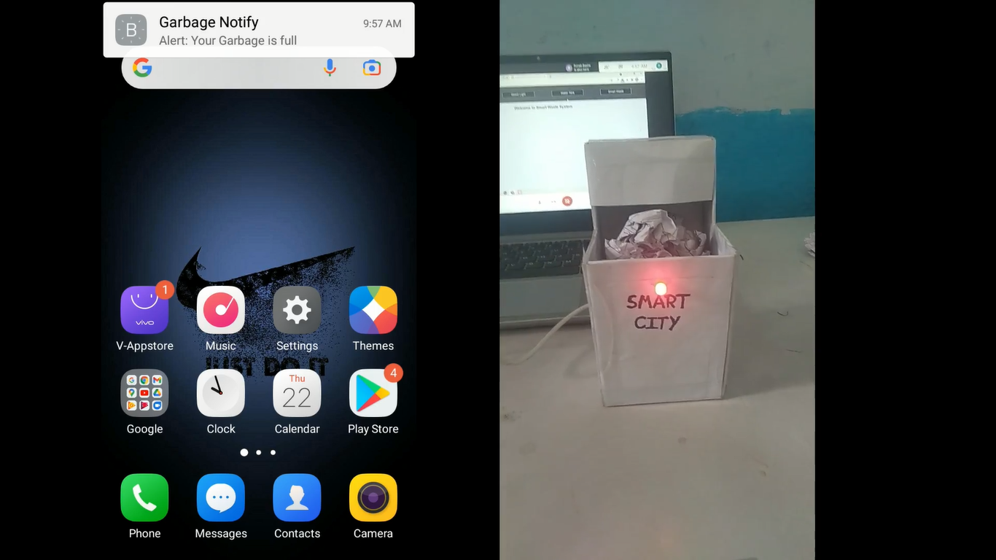

#### Automatic Street Light

#### 

#### 

#### 

#### 

#### Smart Water System

